**Database Technologies**

**UE19CS344**

**6th Semester, Academic Year 2021-22**

Week #: 4 - B+ Trees

(Lab 4)

Date: 8/2/2022

|  |  |  |
| --- | --- | --- |
| Name :  SUMUKH RAJU BHAT | SRN :  PES1UG19CS519 | Section :  H |

**Insertion in B+ trees:**

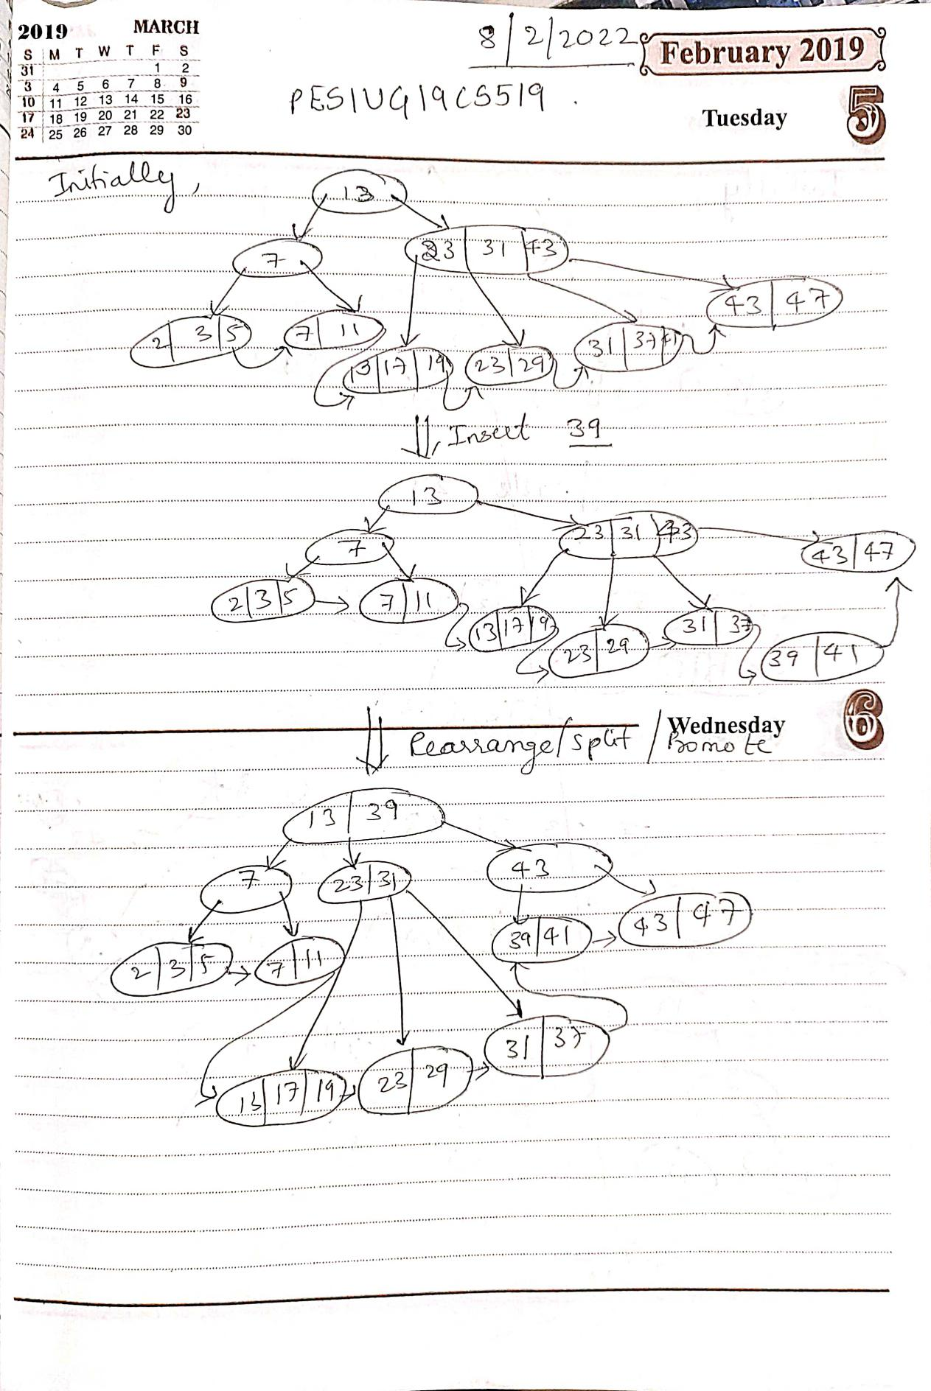

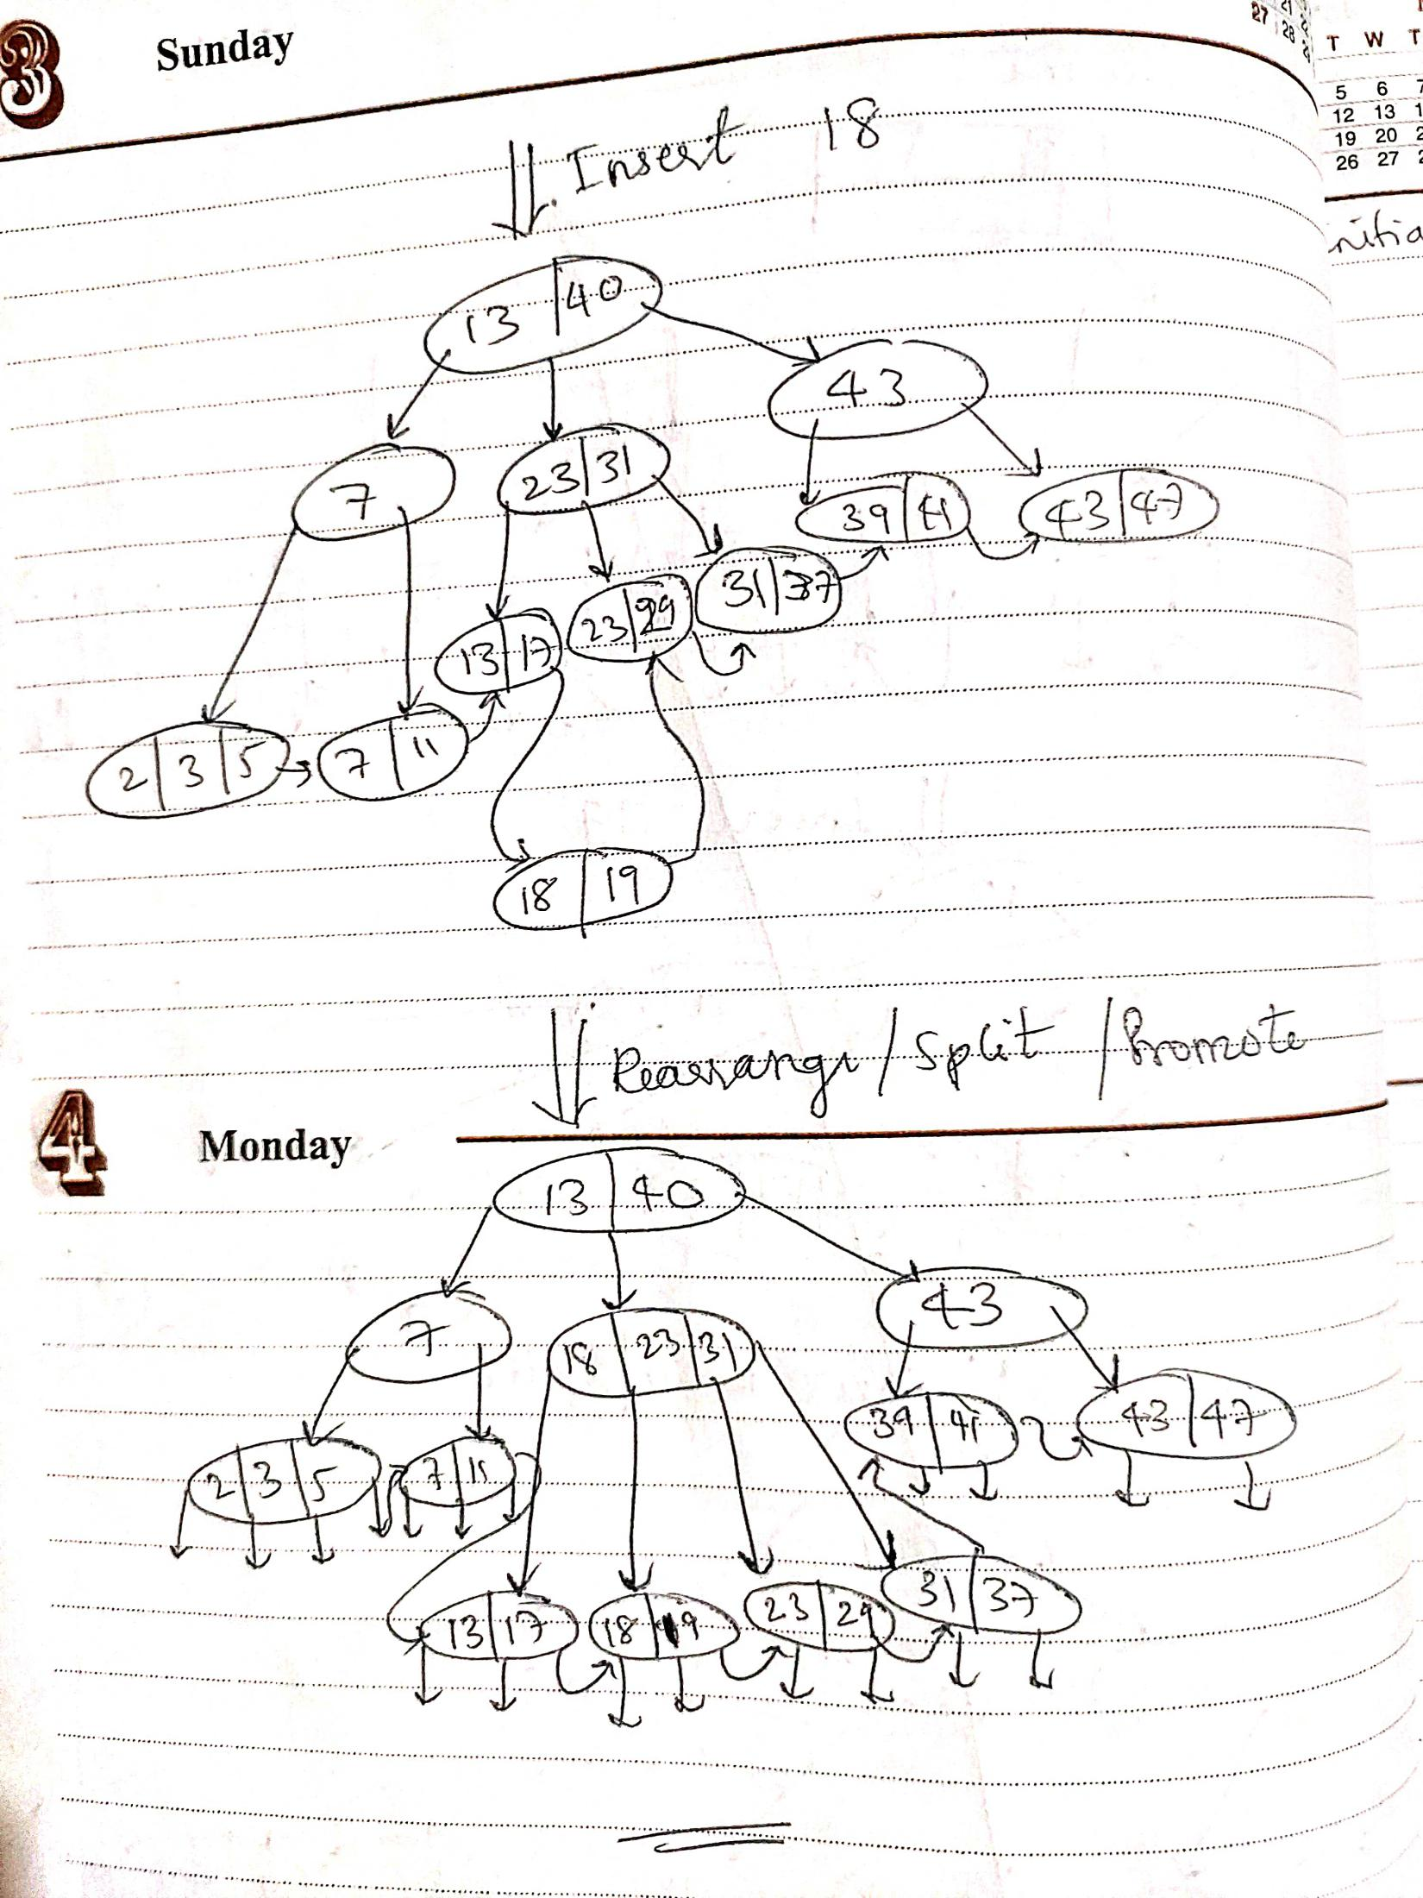

1. **Deletion in B+ Trees:**

